MOTION DETECTION SYSTEM USING ARDUINO NANO & RCWL-0516 DOPPLER RADAR

## A MINI PROJECT

*Submitted by*

In Partial Fulfilment of the Requirements

for the Degree of

**BACHELOR OF TECHNOLOGY**



**DEPARTMENT OF ELECTRONICS AND COMMUNICATION ENGINEERING**

**COLLEGE OF ENGINEERING AND TECHNOLOGY SRM INSTITUTE OF SCIENCE AND TECHNOLOGY KATTANKULATHUR - 603 203**

## APRIL/MAY 2025

## ABSTRACT

This project presents the development of a motion detection system using the RCWL-0516 Doppler Radar Sensor interfaced with an Arduino Nano. Motion detection is vital in fields like security, automation, and smart technologies. Traditional sensors, like PIR modules, often face limitations due to environmental sensitivity and mechanical constraints. To address these issues, this system leverages microwave-based sensing as a reliable alternative.

The RCWL-0516 operates on the Doppler principle, emitting microwaves and detecting frequency shifts caused by motion. It is compact, low-cost, and capable of sensing movement through non-metallic materials like plastic and glass. The Arduino Nano processes the sensor's digital output and triggers a response when motion is detected.

The system was implemented by establishing hardware connections, coding via the Arduino IDE, and testing in real-time scenarios. It successfully detected motion up to 7 meters with quick response time.

This project confirms the effectiveness of using the RCWL-0516 sensor with Arduino for motion detection in home automation, and security applications.

## ACKNOWLEDGEMENT

We take this opportunity to express our sincere gratitude for the valuable guidance, encouragement, and continuous support received throughout the duration of this project. The expert insights and constructive feedback provided at each stage were instrumental in shaping the direction and outcome of the work.

We would also like to thank the department for providing the necessary resources, infrastructure, and a conducive academic environment that facilitated smooth execution of the project. The availability of laboratory facilities and technical assistance greatly contributed to the practical implementation and testing phases.

Our sincere appreciation extends to all faculty members and technical staff whose inputs and support helped in resolving challenges and enhancing the quality of the project. Their involvement, whether direct or indirect, has been immensely helpful.

We also wish to thank peers and fellow students for their encouragement, insightful discussions, and moral support throughout the process. Their companionship added value and motivation during this academic endeavor.

**Signature**

**TABLE OF CONTENTS**

|  |  |  |
| --- | --- | --- |
| **CHAPTER** | **TITLE** | **PAGE** |
| **NO.** | **ABSTRACT** | **NO.**  3 |
| **1** | **ACKNOWLEDGEMENT**  **INTRODUCTION** | 4  7 |
| **2** | **PROBLEM STATEMENT** | 8 |
| **3** | **OBJECTIVES** | 9 |
| **4** | **SYESTEM DIAGRAM AND**  **DESCRIPTION** | 10 |
| **5** | **METHODOLOGY AND**  **IMPLEMENTATION** | 11 |
| **6** | **RESULTS AND DISCUSSION** | 15 |
| **7** | **CONCLUSION AND FUTURE** |  |
|  | **WORKS** | 18 |
|  | 7.1 CONCLUSION | 18 |
|  | 7.2 FUTURE WORKS | 18 |
|  | **REFERENCES** | 19 |

**CHAPTER 1**

**INTRODUCTION**

# The Background of the Topic

RCWL-0516 is a microwave sensor that operates using microwave signals at around 3.2 GHz. It emits continuous waves and detects motion by analysing the Doppler shift in the reflected signals caused by moving objects. Unlike infrared (PIR) sensors, it can detect motion through non-metallic materials like plastic or glass and works reliably in both light and dark environments. Its high sensitivity, wide detection range, and ability to sense small movements make it ideal for motion detection in automation and security systems. A Doppler radar sensor like the RCWL-0516 works by emitting microwave signals and detecting motion based on the Doppler effect. When these signals hit a moving object, the frequency of the reflected waves changes—this is called the Doppler shift. If an object moves toward the sensor, the frequency increases; if it moves away, the frequency decreases. The sensor compares the transmitted and received signals to detect this shift. If motion is detected, the sensor sends a signal (usually HIGH) to indicate movement. It can sense motion through non-metallic objects and is commonly used in automation, security, and smart devices. Interfacing such a sensor with a microcontroller allows for easy integration into projects that require real-time motion detection and tracking. With its low cost and ease of use, the RCWL-0516 provides a valuable tool for hobbyists, engineers, and researchers working on projects involving proximity or motion-based systems.

# Importance of the Project

The RCWL-0516 sensor is highly useful in the development of smart systems, where detecting movement is critical. The ability to interface this sensor with a microcontroller like the Arduino Nano opens possibilities for creating more intelligent devices that can react to motion in real time. Applications range from home automation, smart lighting systems, and security alarms, to robotics and smart devices. The importance of this project lies in understanding the integration process of a microwave radar sensor with a microcontroller, learning about signal processing, and using this sensor in various real-time applications.

# Overview of the Report

This report will provide a comprehensive look at the process of interfacing the RCWL-0516 Doppler Radar Sensor with a microcontroller, focusing on the Arduino Nano. It will cover the problem being solved, the project objectives, and a detailed methodology. The report will also present a system diagram, an explanation of each component, step-by-step instructions for implementation, and the results obtained from the system.

**CHAPTER 2**

## PROBLEM STATEMENT

Motion detection is an essential component in security and automation systems. Traditional methods, such as passive infrared (PIR) sensors, have limitations in terms of the range and ability to detect motion through certain materials. The motivation behind this project is to build an affordable, compact, and effective motion detection system using the RCWL-0516 Doppler radar sensor and Arduino NANO. The primary problem being addressed is to improve the accuracy and detection capability of motion sensors for various applications.

**CHAPTER 3**

## OBJECTIVES

The main objectives of this project are:

* To understand the working principle of the RCWL-0516 Doppler Radar Sensor.
* To design a circuit that connects the RCWL-0516 sensor to the Arduino Nano.
* To develop an efficient program that processes data from the sensor.
* To trigger specific actions (like turning on an LED) when motion is detected.
* To demonstrate how this sensor can be used in real-time applications like security systems or automation.
* To document the setup and findings for future reference and expansion of the project.

**CHAPTER 4**

## SYSTEM DIAGRAM AND DESCRIPTION

### Scope of the project

This project involves designing and implementing a motion detection system using the RCWL-0516 Doppler radar sensor interfaced with the Arduino NANO. The scope includes the sensor’s functionality, integration with the microcontroller, and the development of a simple output system (such as activating an LED or buzzer). The system can be used in various applications, such as security systems, home automation, and motion-sensitive devices.

### Circuit Diagram

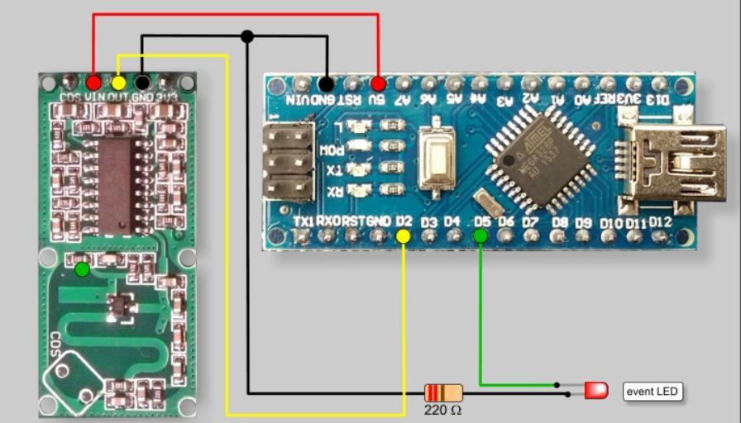

Project Modules

1. RCWL-0516 Sensor Module: The sensor detects motion through microwave signals.
2. Arduino NANO: Processes the signals from the sensor and triggers output devices.
3. Output Device: Could be an LED, buzzer, or relay to activate another system.
4. Power Supply: Powers the entire system.

**CHAPTER 5**

## METHODOLOGY AND IMPLEMENTATION

#### Introduction

This chapter presents the methodology and implementation details of the project titled "Interfacing RCWL-0516 Doppler Radar Sensor with Arduino" *.*The methodology outlines the step-by-step approach adopted to achieve the project objectives, starting from system design, component selection, to integration and testing. The RCWL-0516 is a microwave motion sensor capable of detecting human presence and movement using Doppler effect principles. When integrated with the Arduino NANO, it serves as an effective, compact, and low-cost motion detection system. The design of the system involves selecting appropriate hardware components and writing embedded software to ensure seamless interfacing and data acquisition. The implementation part focuses on assembling the components, programming the microcontroller, and validating the sensor's performance under different scenarios. The goal of this chapter is to explain how the theoretical design was translated into a working prototype and to provide a detailed account of the tools, techniques, and resources used in the development process.

Design/Methods

The design of the motion detection system using the RCWL-0516 Doppler Radar Sensor and Arduino NANO follows a modular and systematic approach. The system is designed to detect motion using microwave sensing technology and respond accordingly by triggering an output signal, such as lighting an LED.

#### Algorithm

1. Start the Arduino system.
2. Initialize the input pin connected to the RCWL-0516 sensor.
3. Read the output signal from the sensor.
4. If motion is detected (sensor Output == HIGH), then:
   1. Turn ON the output device (LED/Buzzer).
   2. Display “Motion Detected” on the serial monitor.
5. Else,
   1. Keep output device OFF.
6. Repeat the process continuously using the loop function.

Code

int Sensor = 2; // RCWL sensor output connected to digital pin 2

int LED = 5; // LED connected to digital pin 5

int flg = 0; // Flag to track motion detection state

void setup() {

Serial.begin(9600); // Start serial communication pinMode(Sensor, INPUT); // Set sensor pin as input pinMode(LED, OUTPUT); // Set LED pin as output Serial.println("Waiting for motion...");

}

void loop() {

int val = digitalRead(Sensor); // Read sensor value

if ((val > 0) && (flg == 0)) { digitalWrite(LED, HIGH); // Turn on LED Serial.println("Motion Detected");

flg = 1; // Set flag to indicate motion detected

}

if (val == 0) {

digitalWrite(LED, LOW); // Turn off LED if (flg == 1) {

Serial.println("No Motion");

}

flg = 0; // Reset flag

}

delay(100); // Small delay to prevent serial spamming

Hardware Requirements

|  |  |
| --- | --- |
| **Component** | **Quantity** |
| Arduino NANO | 1 |
| RCWL-0516 Doppler Sensor | 1 |
| LED | 1 |
| Resistors (220 ohm) | 1 |
| Breadboard | 1 |
| Jumper Wires | As needed |
| USB Cable (for programming) | 1 |
| Power Supply(5V) | 1 |

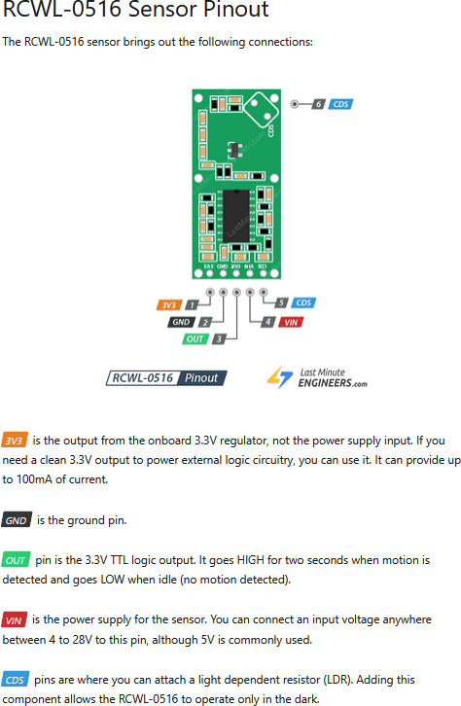

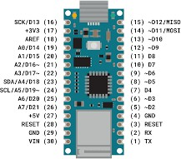Arduino Nano Pinout

Software Requirements

* + - Arduino IDE – for writing and uploading the code to
    - Arduino NANO Serial Monitor – for monitoring sensor outputs and debugging
    - Windows/Linux/Mac OS – any platform compatible with ArduinoIDE

**CHAPTER 6**

## RESULTS AND DISCUSSION

This chapter outlines the outcomes of implementing and testing the motion detection system using the RCWL-0516 Doppler Radar Sensor with Arduino NANO. The results obtained from simulations and the working prototype are discussed in detail to evaluate system performance and reliability.

#### Simulation Results

Since the RCWL-0516 is a hardware sensor based on microwave motion detection, traditional simulation tools (like Proteus or TinkerCad) provide limited support for its behaviour. However, portions of the circuit, including output responses like LEDs and buzzers, were simulated using basic Arduino IDE serial outputs to validate logical functioning of the code.

Key observations from simulation:

* The sensor’s HIGH signal was accurately read by the Arduino.
* LED control logic responded correctly to motion detection.
* Serial messages such as “Motion Detected” were displayed as expected.

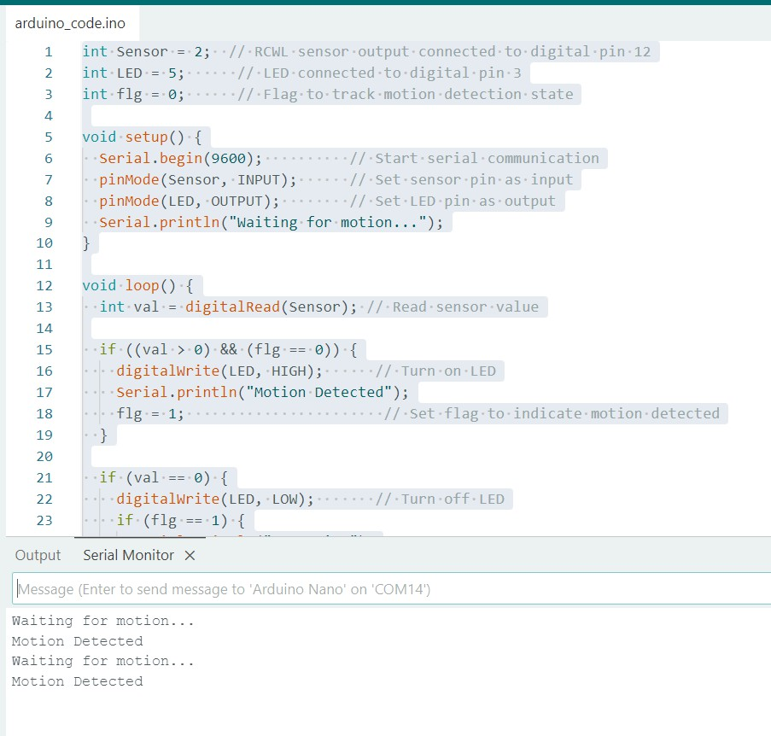

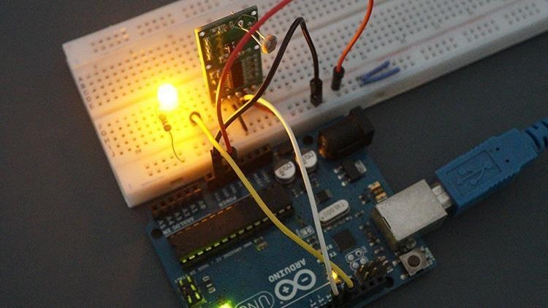Prototype/Working Model

* Arduino NANO was programmed and interfaced with the RCWL-0516 sensor.
* The OUT pin of the sensor was connected to digital pin D2 of the Arduino.
* An LED was connected to digital pin D13 to indicate motion.
* The sensor detected motion reliably within a range of approximately 6 –7 meters.

Prototype demonstration:

* + When a person moved within the detection range, the LED turned ON and the serial

monitor displayed “Motion Detected”.

* + When no motion was present, the LED remained OFF and no output was triggered.

#### Performance Analysis

The system performance was evaluated based on several parameters:

|  |  |
| --- | --- |
| **Parameter** | **Observation** |
| **Detection Range** | ~6–7 meters (clear line of sight) |
| **Response Time** | Less than 1 second |
| **Power Consumption** | Low (~3.3V–5V operation, ideal for IoT use) |
| **False Positives** | Minimal in controlled environment |
| **Ease of Integration** | Easy to use with Arduino NANO |

**CHAPTER 7**

## CONCLUSION AND FUTURE WORKS

##### CONCLUSION

In this project, we successfully designed and implemented a motion detection system using the RCWL-0516 Doppler Radar Sensor interfaced with an Arduino NANO. The system was capable of detecting motion reliably within a range of 6–7 meters and triggering corresponding output signals (such as lighting an LED or activating a buzzer).

Compared to traditional Passive Infrared (PIR) sensors, the RCWL-0516 showed improved sensitivity, faster response time, and the ability to detect motion through certain non-metallic materials, making it highly suitable for indoor automation and security applications.

The simplicity of interfacing, low power consumption, and efficient performance of the system demonstrate the viability of using the RCWL-0516 sensor in embedded projects. This work provides a strong foundation for more advanced implementations in real-world smart monitoring systems.

##### FUTURE WORKS

While the current implementation achieved its intended objectives, the system can be improved and extended in the following ways:

* + Integration with IoT Platforms: Future versions can incorporate Wi-Fi or Bluetooth modules (like ESP8266 or HC-05) to send motion alerts to smartphones or cloud dashboards in real-time.
  + Multiple Sensor Setup: Combining multiple RCWL-0516 sensors can increase coverage area and improve motion tracking precision in large spaces.
  + Advanced Output Control: Integrating smart lights or servo mechanisms could enable automatic actions like opening doors, adjusting lights, or triggering alarms.
  + Machine Learning Integration: With additional sensors and data processing, it may be possible to distinguish between human motion and other moving objects to reduce false triggers.
  + Mobile App Interface: A companion app can be developed to provide remote control and visualization of sensor activity logs.

## REFERENCES

1. RCWL-0516 Microwave Radar Sensor Datasheet. (n.d.). *DFRobot Wiki*. Retrieved from https://wiki.dfrobot.com/RCWL_0516_Microwave_Radar_Sensor_Module_SKU_SEN 0192
2. Arduino Nano Board. (n.d.). *Arduino Official Store*. Retrieved from https://store.arduino.cc/products/arduino-nano
3. Al-Hasan, A. I., & Hossain, M. A. (2019). Smart security system using PIR sensor and GSM module. *International Journal of Computer Applications*, *177*(19), 1–4.
4. Hussain, N. A., Zainal Abidin, H. H., & Zulkifli, N. H. (2019, August). Motion detection using microwave Doppler radar sensor for security system. In *Proceedings of the IEEE 6th International Conference on Smart Instrumentation, Measurement and Applications (ICSIMA)* (pp. 1–5). Kuala Lumpur, Malaysia.
5. Wahid, A., & Rahman, M. S. (2020). Design of a low-cost smart home automation system using Arduino. *International Journal of Engineering Research and Technology (IJERT)*, *9*(5), 1230–1233.
6. Sharma, S. K., & Patil, S. (2020). Comparative study of PIR and microwave sensors for human detection. *International Research Journal of Engineering and Technology (IRJET)*, *7*(6), 1229–1233.